# APPPENDIX 1 - DETAIL DATA

This appendix provides detailed program data. Charts and tables in this section may be copied into the Data Analysis section of the Current Status section.

#### Headcount

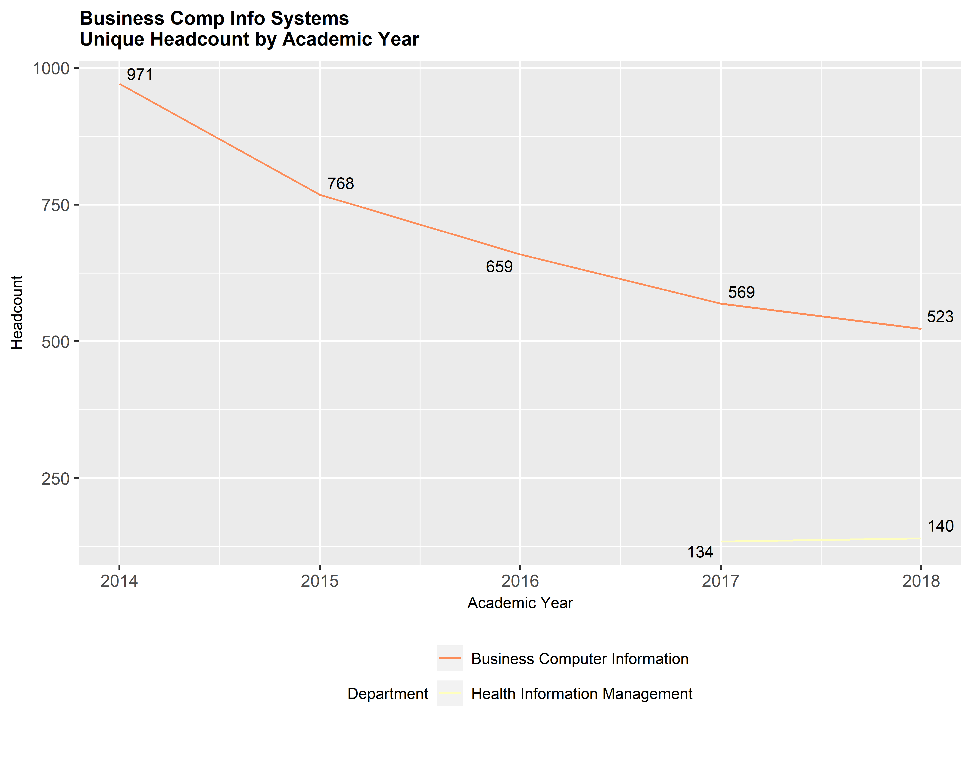

#### Gender

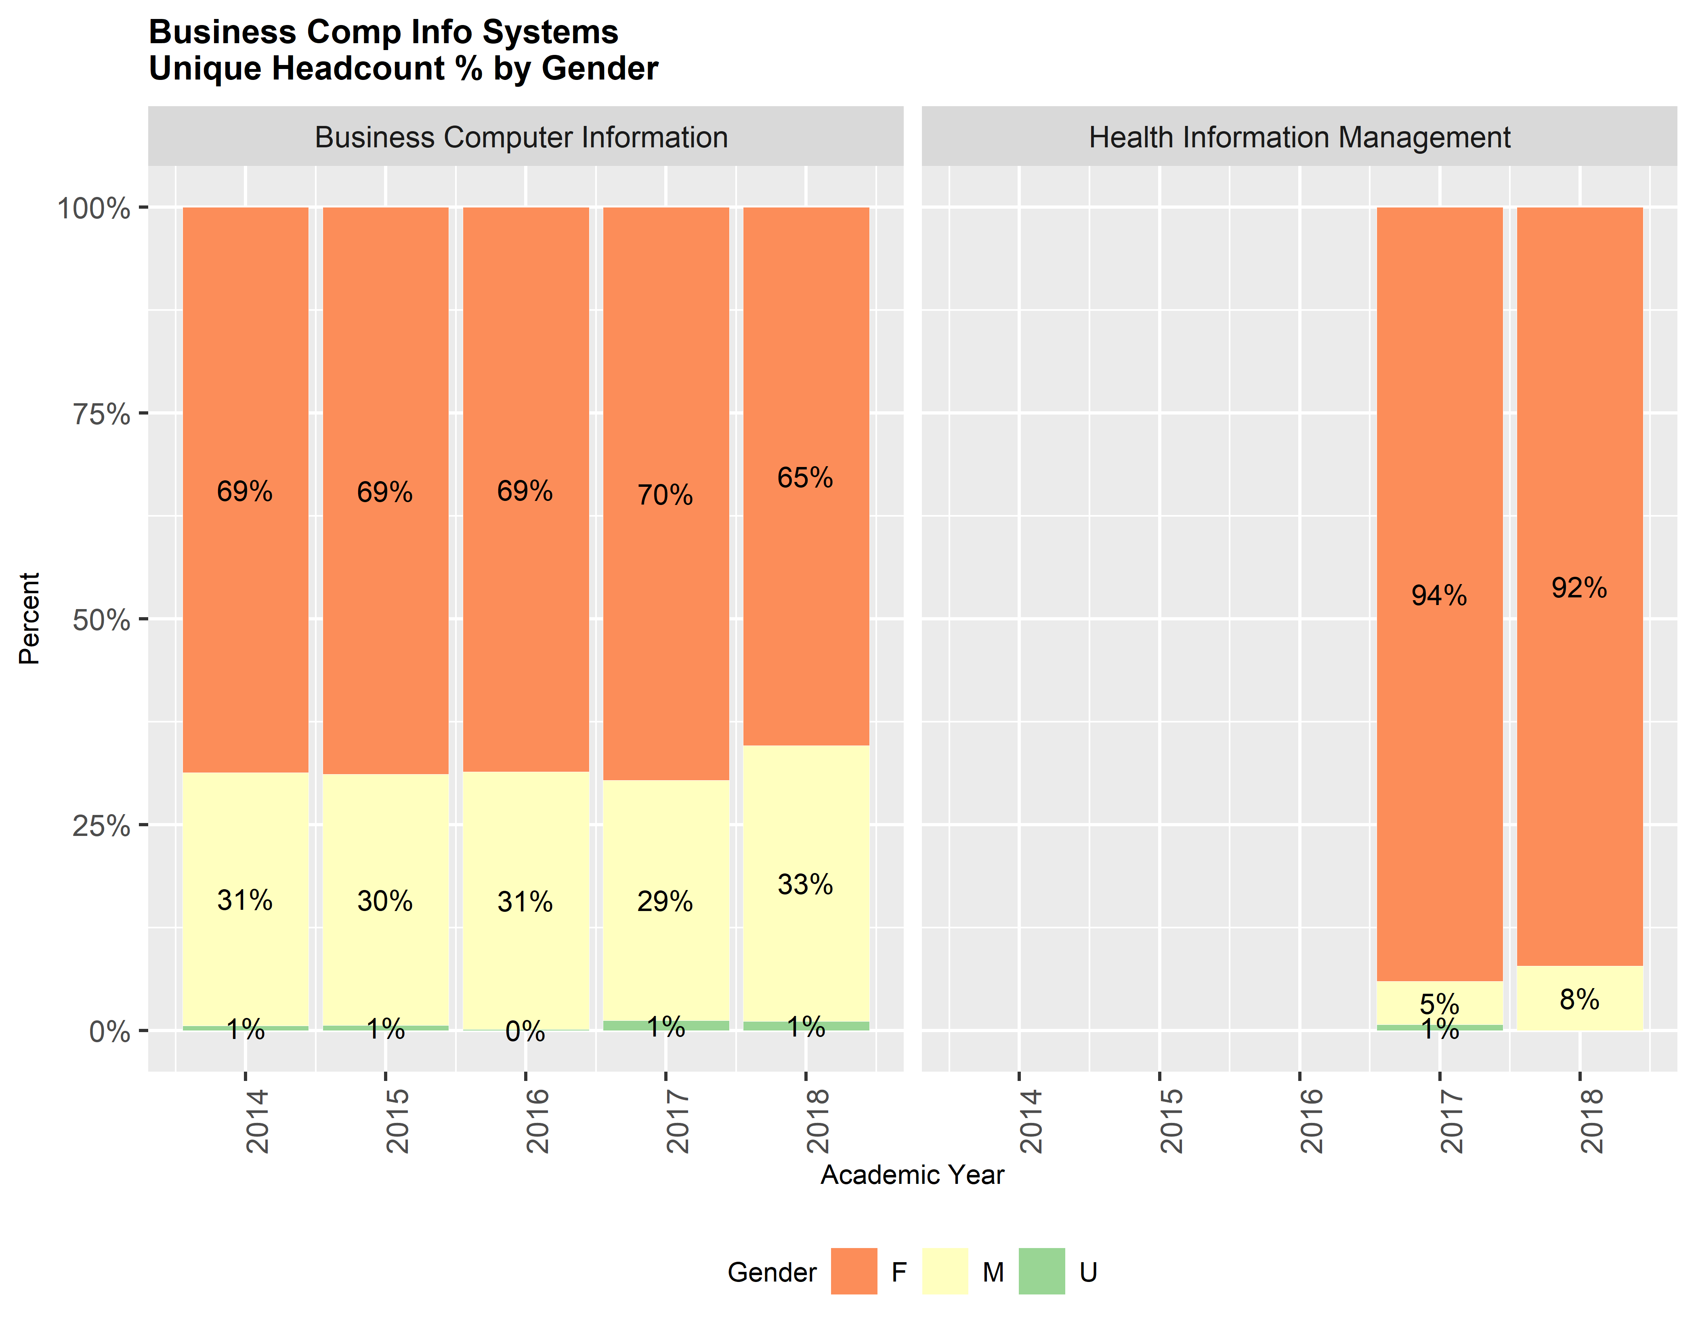

#### Age

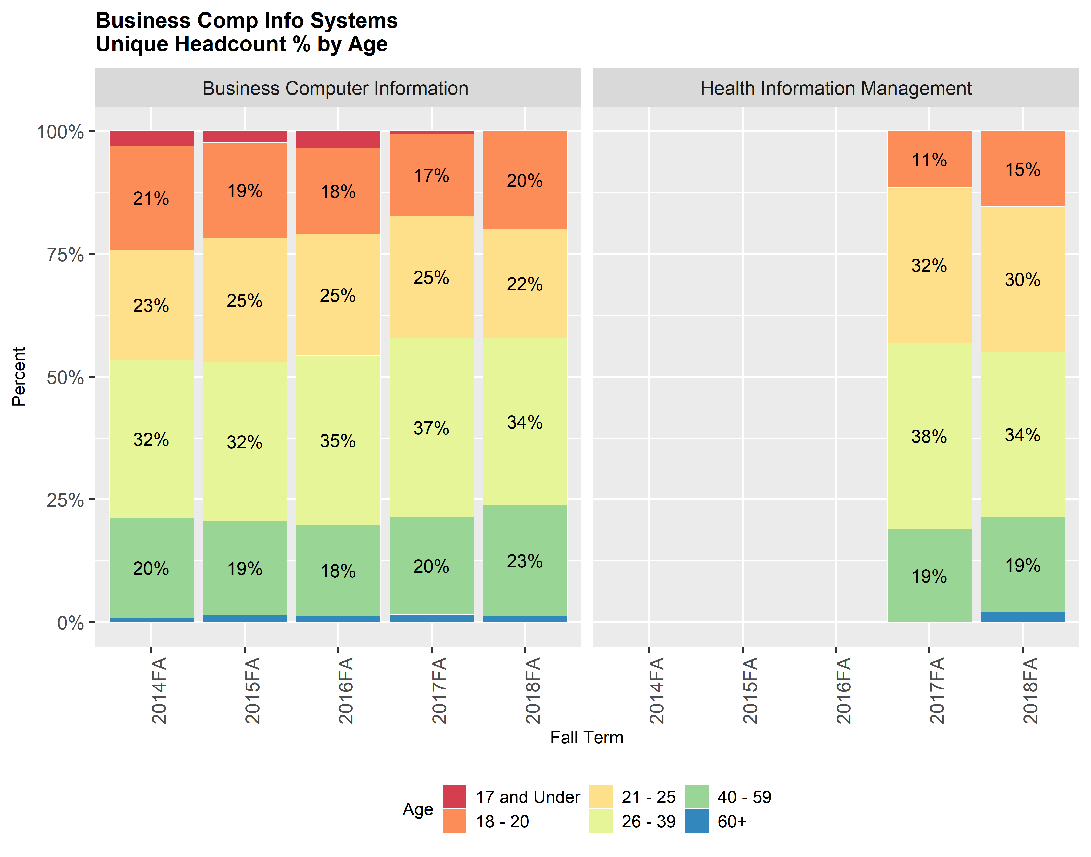

#### Student Ethnicity

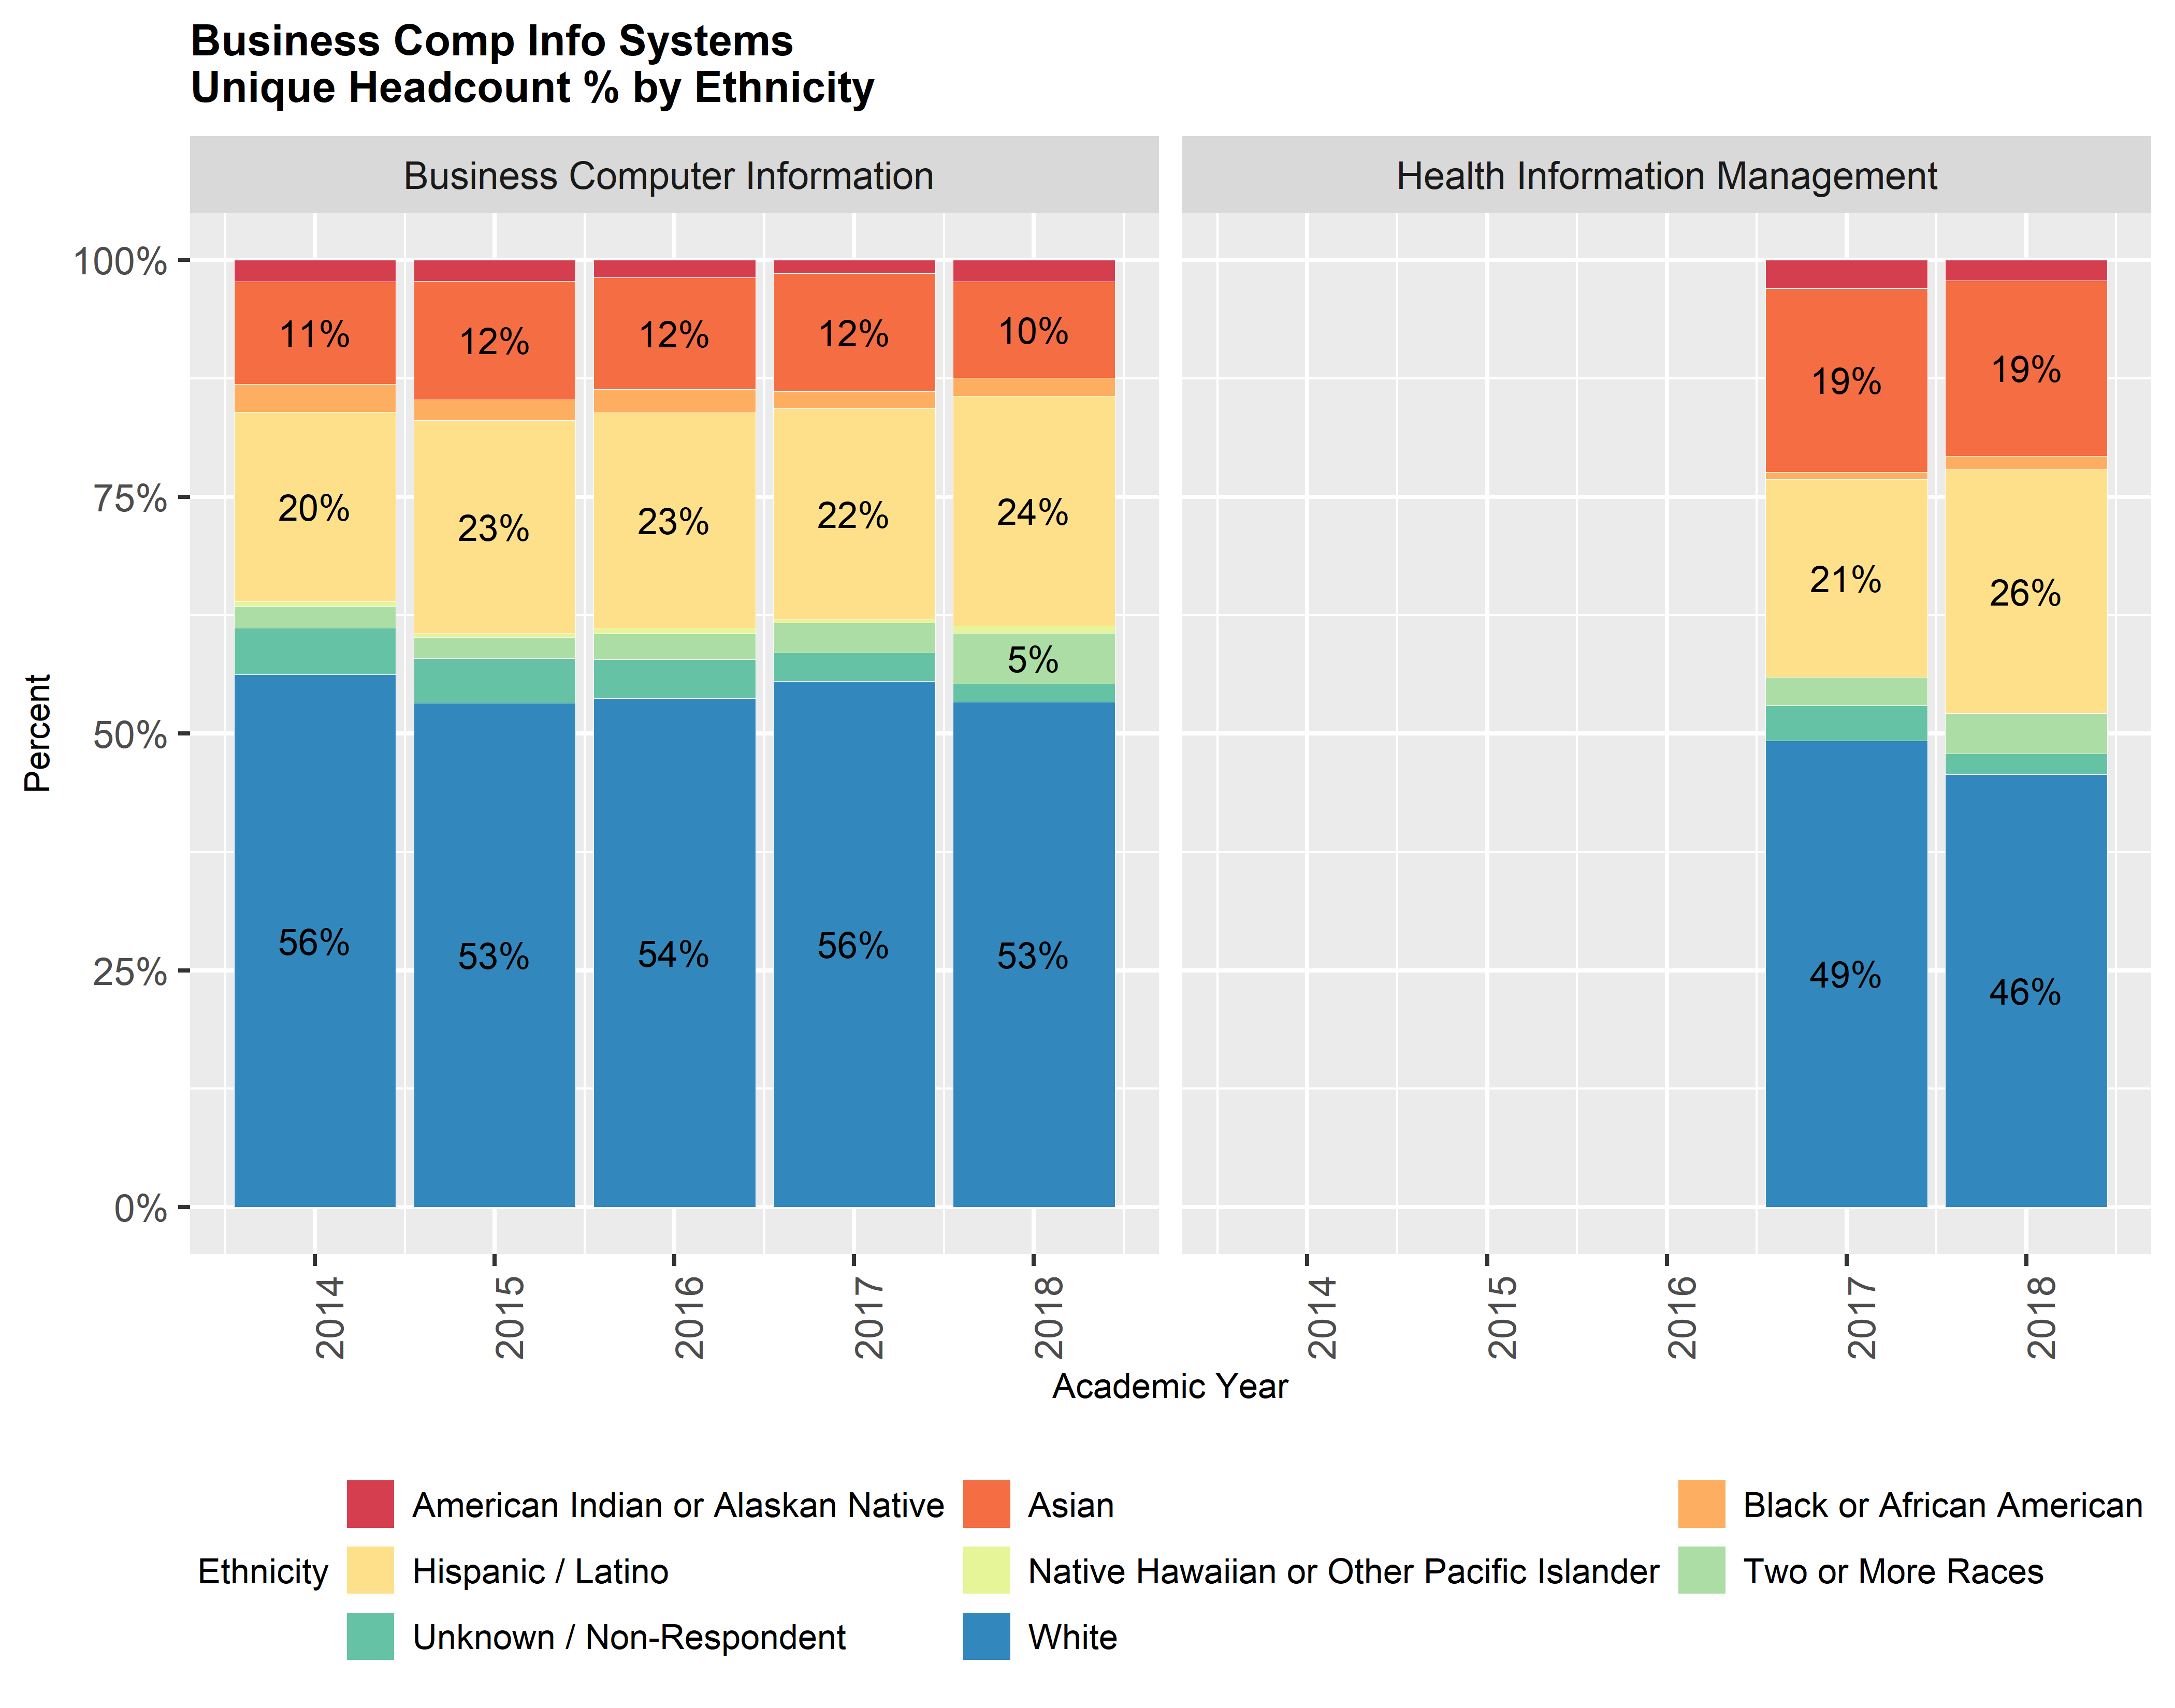

#### Student Income Status

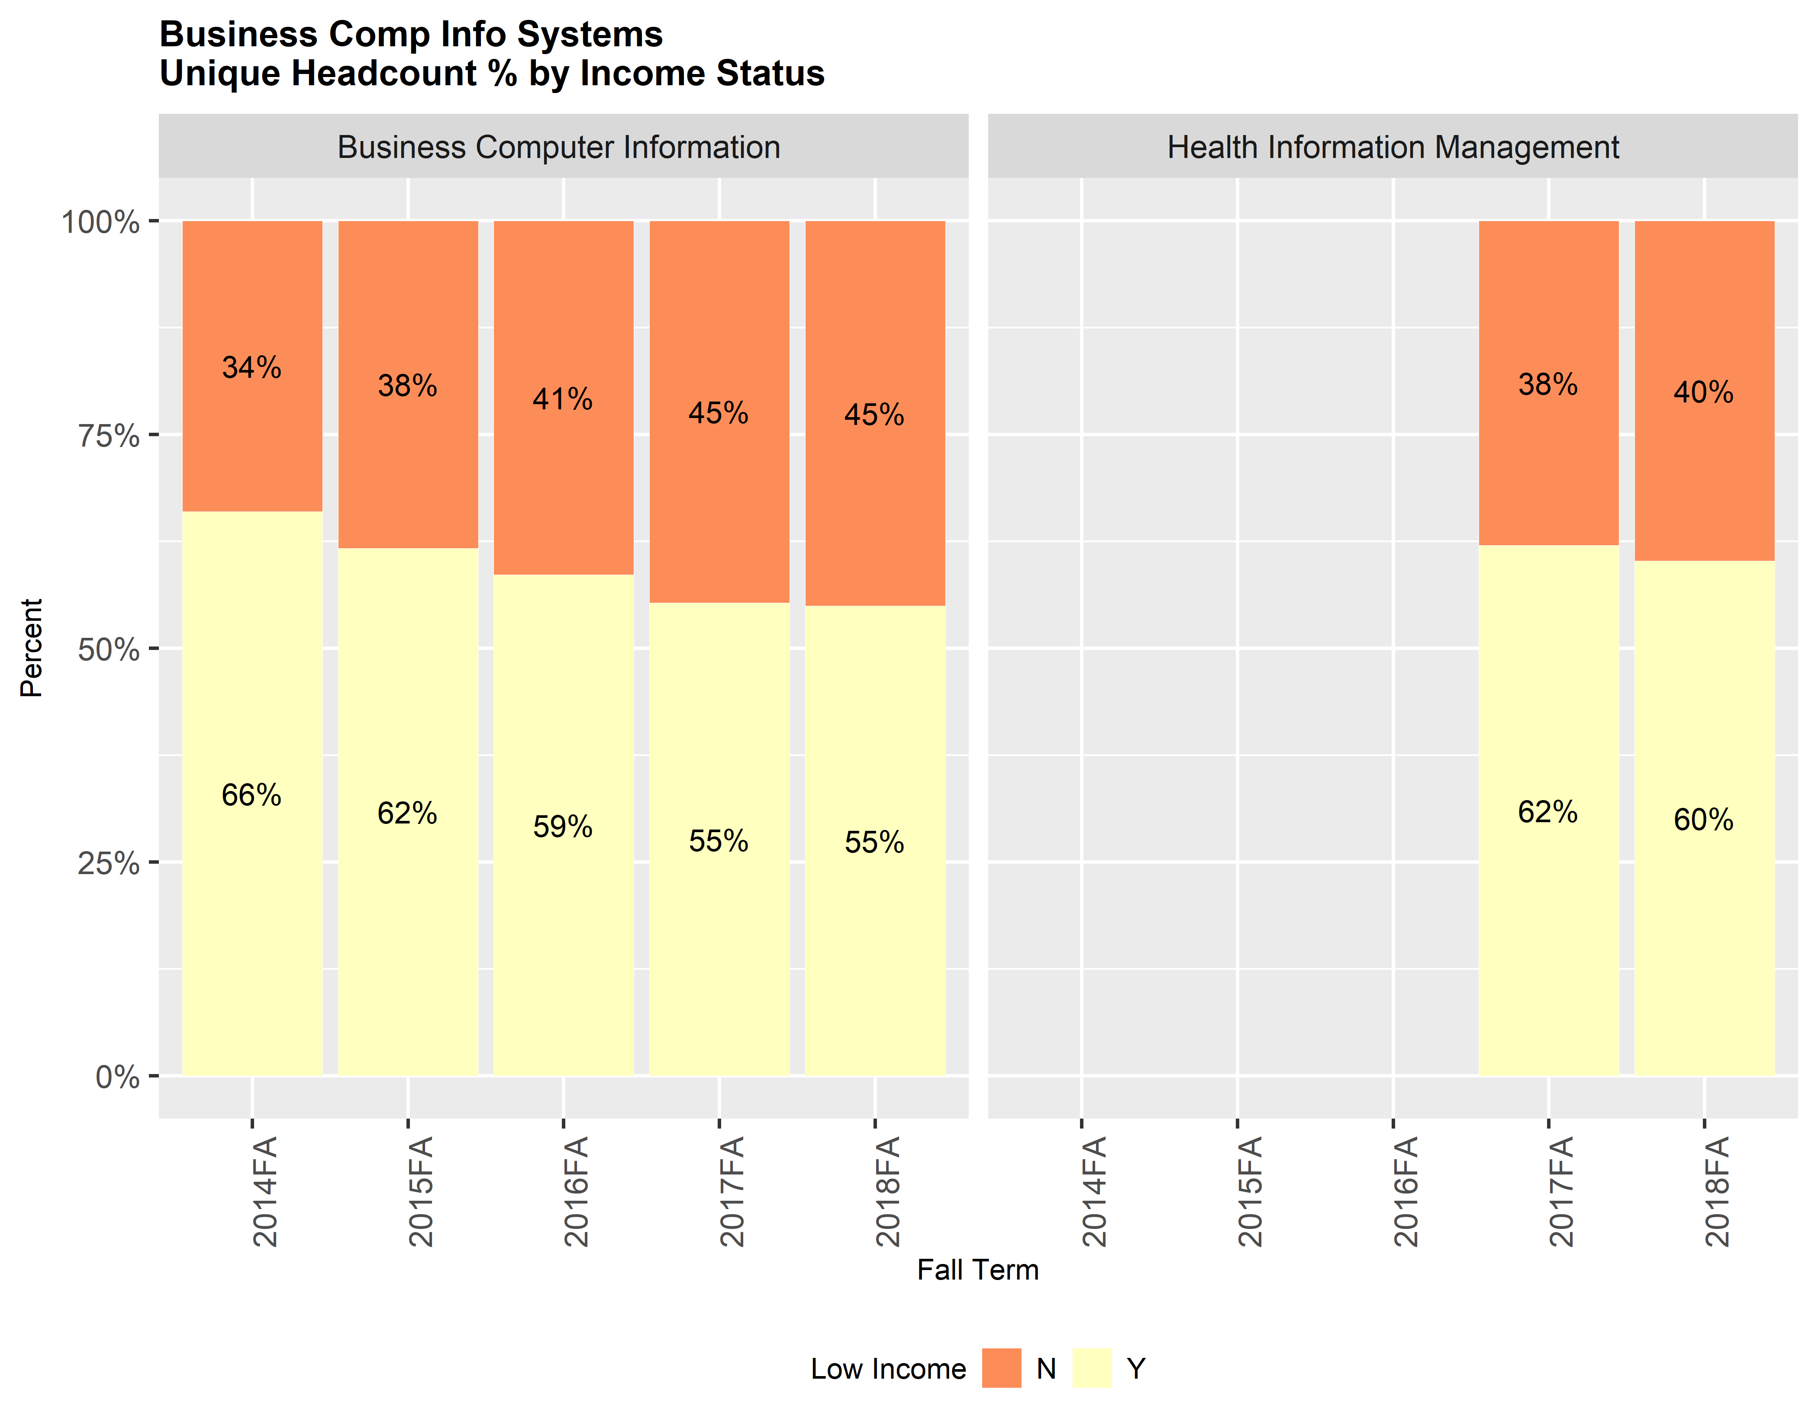

#### Special Populations

% of Program Students in Special Populations

|  |  |  |  |
| --- | --- | --- | --- |
| Department | Identified as DSPS | Identified as Foster Youth | Identified as Veterans |
| Business Computer Information | 11.7% | 3.4% | 3.5% |
| Health Information Management | 10.5% | 3.4% | 1.7% |
| Butte College | 5.9% | 3.2% | 3.3% |

###### Page Break

#### Fill Rates by Course

Number of Courses Offered; Enrollments, and Fill Rates by Mode

|  |  |  |  |  |  |  |  |  |  |  |  |  |
| --- | --- | --- | --- | --- | --- | --- | --- | --- | --- | --- | --- | --- |
| Dept | Loc | Mode | Crse | Sec_2016 | Sec_2017 | Sec_2018 | Enrl_2016 | Enrl_2017 | Enrl_2018 | FR_2016 | FR_2017 | FR_2018 |
| Business Computer Information | Chico Center | F2F | BCIS-12 | 2 | NA | NA | 33 | NA | NA | 0.47 | NA | NA |
| Business Computer Information | Chico Center | F2F | BCIS-13 | 2 | 2 | 2 | 52 | 40 | 37 | 0.87 | 0.67 | 0.62 |
| Business Computer Information | Chico Center | F2F | BCIS-18 | 3 | 2 | 2 | 72 | 39 | 36 | 0.80 | 0.65 | 0.60 |
| Business Computer Information | Chico Center | F2F | BCIS-20 | NA | 1 | 2 | NA | 33 | 26 | NA | 1.10 | 0.43 |
| Business Computer Information | Chico Center | F2F | BCIS-24 | 1 | 2 | 1 | 13 | 17 | 7 | 0.41 | 0.27 | 0.22 |
| Business Computer Information | Chico Center | F2F | BCIS-28 | NA | 1 | NA | NA | 20 | NA | NA | 0.67 | NA |
| Business Computer Information | Chico Center | F2F | BCIS-33 | 2 | 2 | 2 | 67 | 28 | 27 | 0.96 | 0.40 | 0.39 |
| Business Computer Information | Chico Center | F2F | BCIS-46 | 2 | 2 | 2 | 46 | 22 | 32 | 0.66 | 0.31 | 0.46 |
| Business Computer Information | Chico Center | F2F | BCIS-47 | NA | NA | 1 | NA | NA | 10 | NA | NA | 0.33 |
| Business Computer Information | Chico Center | F2F | BCIS-51 | 1 | 1 | 1 | 21 | 16 | 12 | 0.60 | 0.46 | 0.34 |
| Business Computer Information | Chico Center | F2F | BCIS-62 | 1 | NA | NA | 28 | NA | NA | 1.12 | NA | NA |
| Business Computer Information | Chico Center | F2F | BCIS-63 | 1 | NA | NA | 24 | NA | NA | 0.96 | NA | NA |
| Business Computer Information | Chico Center | F2F | BCIS-70K | NA | NA | 1 | NA | NA | 9 | NA | NA | 0.32 |
| Business Computer Information | Chico Center | F2F | BCIS-75 | 1 | NA | NA | 24 | NA | NA | 0.75 | NA | NA |
| Business Computer Information | Chico Center | F2F | BCIS-76 | 1 | NA | NA | 21 | NA | NA | 0.66 | NA | NA |
| Business Computer Information | Chico Center | F2F | BCIS-81 | 1 | NA | 1 | 18 | NA | 20 | 0.72 | NA | 0.80 |
| Business Computer Information | Chico Center | F2F | BCIS-84 | NA | 1 | 1 | NA | 6 | 9 | NA | 0.24 | 0.36 |
| Business Computer Information | Chico Center | F2F | BCIS-85 | 1 | 1 | 1 | 20 | 12 | 14 | 0.67 | 0.40 | 0.47 |
| Business Computer Information | Main Campus | F2F | BCIS-12 | 3 | NA | NA | 58 | NA | NA | 0.67 | NA | NA |
| Business Computer Information | Main Campus | F2F | BCIS-13 | 4 | 4 | 4 | 93 | 83 | 79 | 0.80 | 0.72 | 0.68 |
| Business Computer Information | Main Campus | F2F | BCIS-15 | NA | 1 | 1 | NA | 21 | 16 | NA | 0.70 | 0.53 |
| Business Computer Information | Main Campus | F2F | BCIS-18 | 4 | 3 | 3 | 114 | 75 | 58 | 0.95 | 0.85 | 0.66 |
| Business Computer Information | Main Campus | F2F | BCIS-20 | 3 | 2 | 3 | 77 | 49 | 58 | 0.89 | 0.83 | 0.67 |
| Business Computer Information | Main Campus | F2F | BCIS-24 | 2 | 2 | 1 | 45 | 23 | 8 | 0.78 | 0.39 | 0.28 |
| Business Computer Information | Main Campus | F2F | BCIS-31 | 1 | NA | NA | 14 | NA | NA | 0.56 | NA | NA |
| Business Computer Information | Main Campus | F2F | BCIS-33 | 4 | 2 | 2 | 113 | 53 | 23 | 0.97 | 0.90 | 0.39 |
| Business Computer Information | Main Campus | F2F | BCIS-46 | 3 | 2 | 1 | 60 | 39 | 12 | 0.69 | 0.67 | 0.41 |
| Business Computer Information | Main Campus | F2F | BCIS-47 | 1 | 1 | 1 | 28 | 20 | 13 | 0.93 | 0.67 | 0.43 |
| Business Computer Information | Main Campus | F2F | BCIS-50 | 1 | 1 | 1 | 24 | 14 | 10 | 0.96 | 0.56 | 0.40 |
| Business Computer Information | Main Campus | F2F | BCIS-51 | 2 | 2 | NA | 44 | 26 | NA | 0.76 | 0.45 | NA |
| Business Computer Information | Main Campus | F2F | BCIS-62 | 1 | NA | NA | 27 | NA | NA | 1.08 | NA | NA |
| Business Computer Information | Main Campus | F2F | BCIS-63 | 1 | NA | NA | 27 | NA | NA | 1.08 | NA | NA |
| Business Computer Information | Main Campus | F2F | BCIS-70K | 1 | 1 | NA | 33 | 22 | NA | 1.18 | 0.79 | NA |
| Business Computer Information | Main Campus | F2F | BCIS-70L | 2 | NA | NA | 41 | NA | NA | 0.69 | NA | NA |
| Business Computer Information | Main Campus | F2F | BCIS-75 | 2 | NA | NA | 37 | NA | NA | 0.64 | NA | NA |
| Business Computer Information | Main Campus | F2F | BCIS-76 | 1 | NA | NA | 19 | NA | NA | 0.63 | NA | NA |
| Business Computer Information | Main Campus | F2F | BCIS-81 | 1 | 2 | 2 | 26 | 39 | 34 | 1.04 | 0.78 | 0.68 |
| Business Computer Information | Main Campus | F2F | BCIS-84 | 1 | NA | NA | 17 | NA | NA | 0.68 | NA | NA |
| Business Computer Information | Main Campus | F2F | BCIS-85 | 1 | 1 | NA | 22 | 19 | NA | 0.76 | 0.66 | NA |
| Business Computer Information | Main Campus | F2F | BCIS-97 | 1 | 2 | 3 | NA | 2 | 2 | 0.00 | 0.25 | 0.17 |
| Business Computer Information | Main Campus | HYB | BCIS-18 | NA | 4 | 6 | NA | 80 | 119 | NA | 0.67 | 0.64 |
| Business Computer Information | Main Campus | HYB | BCIS-28 | 2 | 1 | 2 | 31 | 15 | 28 | 0.52 | 0.50 | 0.47 |
| Business Computer Information | Main Campus | NET | BCIS-33 | NA | 4 | 6 | NA | 106 | 153 | NA | 0.76 | 0.73 |
| Business Computer Information | Main Campus | NET | BCIS-59 | NA | 1 | 1 | NA | 23 | 26 | NA | 0.77 | 0.87 |
| Business Computer Information | Main Campus | NET | BCIS-60 | NA | 1 | 1 | NA | 15 | 19 | NA | 0.50 | 0.54 |
| Health Information Management | Chico Center | F2F | HIM-58 | NA | 1 | 2 | NA | 34 | 40 | NA | 0.97 | 0.57 |
| Health Information Management | Chico Center | HYB | HIM-64 | NA | 1 | 1 | NA | 13 | 18 | NA | 0.37 | 0.51 |
| Health Information Management | Main Campus | F2F | HIM-63 | NA | 1 | NA | NA | 13 | NA | NA | 0.45 | NA |
| Health Information Management | Main Campus | HYB | HIM-64 | NA | 1 | NA | NA | 11 | NA | NA | 0.31 | NA |
| Health Information Management | Main Campus | NET | HIM-56 | NA | 2 | 2 | NA | 60 | 64 | NA | 0.86 | 0.91 |
| Health Information Management | Main Campus | NET | HIM-62 | NA | 2 | 3 | NA | 62 | 70 | NA | 0.89 | 0.67 |
| Health Information Management | Main Campus | NET | HIM-63 | NA | 1 | 2 | NA | 34 | 60 | NA | 0.97 | 0.86 |
| Health Information Management | Main Campus | NET | HIM-76 | NA | 2 | 1 | NA | 64 | 34 | NA | 0.91 | 0.97 |

###### Page Break

#### Efficiency by Course

Number of FTES; FTEF, and Efficiency by Mode

|  |  |  |  |  |  |  |  |  |  |  |  |  |
| --- | --- | --- | --- | --- | --- | --- | --- | --- | --- | --- | --- | --- |
| Dept | Loc | Mode | Crse | FTES_2016 | FTES_2017 | FTES_2018 | FTEF_2016 | FTEF_2017 | FTEF_2018 | Effcy_2016 | Effcy_2017 | Effcy_2018 |
| Business Computer Information | Chico Center | F2F | BCIS-12 | 3.30 | NA | NA | 0.20 | NA | NA | 16.50 | NA | NA |
| Business Computer Information | Chico Center | F2F | BCIS-13 | 5.20 | 4.00 | 3.70 | 0.20 | 0.20 | 0.20 | 26.00 | 20.00 | 18.50 |
| Business Computer Information | Chico Center | F2F | BCIS-18 | 9.60 | 5.20 | 4.80 | 0.37 | 0.25 | 0.25 | 26.06 | 21.17 | 19.54 |
| Business Computer Information | Chico Center | F2F | BCIS-20 | NA | 3.30 | 2.60 | NA | 0.09 | 0.18 | NA | 36.87 | 14.53 |
| Business Computer Information | Chico Center | F2F | BCIS-24 | 1.30 | 1.70 | 0.70 | 0.08 | 0.16 | 0.08 | 16.48 | 10.77 | 8.87 |
| Business Computer Information | Chico Center | F2F | BCIS-28 | NA | 3.33 | NA | NA | 0.15 | NA | NA | 22.89 | NA |
| Business Computer Information | Chico Center | F2F | BCIS-33 | 2.17 | 0.90 | 0.83 | 0.07 | 0.07 | 0.07 | 32.58 | 13.47 | 12.50 |
| Business Computer Information | Chico Center | F2F | BCIS-46 | 4.60 | 2.20 | 3.20 | 0.19 | 0.19 | 0.19 | 24.73 | 11.83 | 17.20 |
| Business Computer Information | Chico Center | F2F | BCIS-47 | NA | NA | 1.00 | NA | NA | 0.09 | NA | NA | 11.17 |
| Business Computer Information | Chico Center | F2F | BCIS-51 | 2.10 | 1.60 | 1.20 | 0.10 | 0.10 | 0.10 | 21.00 | 16.00 | 12.00 |
| Business Computer Information | Chico Center | F2F | BCIS-62 | 2.80 | NA | NA | 0.10 | NA | NA | 28.00 | NA | NA |
| Business Computer Information | Chico Center | F2F | BCIS-63 | 2.40 | NA | NA | 0.10 | NA | NA | 24.00 | NA | NA |
| Business Computer Information | Chico Center | F2F | BCIS-70K | NA | NA | 0.41 | NA | NA | 0.04 | NA | NA | 9.20 |
| Business Computer Information | Chico Center | F2F | BCIS-75 | 2.40 | NA | NA | 0.10 | NA | NA | 24.00 | NA | NA |
| Business Computer Information | Chico Center | F2F | BCIS-76 | 2.10 | NA | NA | 0.10 | NA | NA | 21.00 | NA | NA |
| Business Computer Information | Chico Center | F2F | BCIS-81 | 0.87 | NA | 0.91 | 0.04 | NA | 0.04 | 19.56 | NA | 20.45 |
| Business Computer Information | Chico Center | F2F | BCIS-84 | NA | 0.27 | 0.41 | NA | 0.04 | 0.04 | NA | 6.26 | 9.39 |
| Business Computer Information | Chico Center | F2F | BCIS-85 | 3.33 | 2.00 | 2.33 | 0.15 | 0.15 | 0.15 | 22.89 | 13.74 | 16.03 |
| Business Computer Information | Main Campus | F2F | BCIS-12 | 5.80 | NA | NA | 0.30 | NA | NA | 19.33 | NA | NA |
| Business Computer Information | Main Campus | F2F | BCIS-13 | 9.30 | 8.30 | 7.90 | 0.40 | 0.40 | 0.40 | 23.25 | 20.75 | 19.75 |
| Business Computer Information | Main Campus | F2F | BCIS-15 | NA | 2.80 | 2.13 | NA | 0.12 | 0.12 | NA | 22.80 | 17.37 |
| Business Computer Information | Main Campus | F2F | BCIS-18 | 15.20 | 10.00 | 7.73 | 0.49 | 0.37 | 0.37 | 30.94 | 27.14 | 20.99 |
| Business Computer Information | Main Campus | F2F | BCIS-20 | 7.70 | 4.90 | 5.80 | 0.27 | 0.18 | 0.27 | 28.68 | 27.37 | 21.60 |
| Business Computer Information | Main Campus | F2F | BCIS-24 | 4.50 | 2.30 | 0.80 | 0.16 | 0.16 | 0.08 | 28.52 | 14.58 | 10.14 |
| Business Computer Information | Main Campus | F2F | BCIS-31 | 0.68 | NA | NA | 0.04 | NA | NA | 15.27 | NA | NA |
| Business Computer Information | Main Campus | F2F | BCIS-33 | 3.60 | 1.69 | 0.72 | 0.13 | 0.07 | 0.07 | 27.06 | 25.40 | 10.85 |
| Business Computer Information | Main Campus | F2F | BCIS-46 | 6.00 | 3.90 | 1.20 | 0.28 | 0.19 | 0.09 | 21.51 | 20.97 | 12.90 |
| Business Computer Information | Main Campus | F2F | BCIS-47 | 3.27 | 2.00 | 1.30 | 0.11 | 0.09 | 0.09 | 30.76 | 22.35 | 14.53 |
| Business Computer Information | Main Campus | F2F | BCIS-50 | 2.40 | 1.40 | 1.00 | 0.10 | 0.10 | 0.10 | 24.00 | 14.00 | 10.00 |
| Business Computer Information | Main Campus | F2F | BCIS-51 | 4.40 | 2.60 | NA | 0.20 | 0.20 | NA | 22.00 | 13.00 | NA |
| Business Computer Information | Main Campus | F2F | BCIS-62 | 2.70 | NA | NA | 0.10 | NA | NA | 27.00 | NA | NA |
| Business Computer Information | Main Campus | F2F | BCIS-63 | 2.70 | NA | NA | 0.10 | NA | NA | 27.00 | NA | NA |
| Business Computer Information | Main Campus | F2F | BCIS-70K | 1.61 | 1.07 | NA | 0.04 | 0.04 | NA | 36.00 | 23.91 | NA |
| Business Computer Information | Main Campus | F2F | BCIS-70L | 1.94 | NA | NA | 0.09 | NA | NA | 21.65 | NA | NA |
| Business Computer Information | Main Campus | F2F | BCIS-75 | 3.70 | NA | NA | 0.20 | NA | NA | 18.50 | NA | NA |
| Business Computer Information | Main Campus | F2F | BCIS-76 | 1.90 | NA | NA | 0.10 | NA | NA | 19.00 | NA | NA |
| Business Computer Information | Main Campus | F2F | BCIS-81 | 1.27 | 1.86 | 1.55 | 0.04 | 0.09 | 0.09 | 28.36 | 20.85 | 17.39 |
| Business Computer Information | Main Campus | F2F | BCIS-84 | 0.83 | NA | NA | 0.04 | NA | NA | 18.85 | NA | NA |
| Business Computer Information | Main Campus | F2F | BCIS-85 | 3.67 | 3.17 | NA | 0.15 | 0.15 | NA | 25.18 | 21.75 | NA |
| Business Computer Information | Main Campus | F2F | BCIS-97 | NA | 0.17 | 0.13 | 0.00 | 0.00 | 0.00 | NA | NA | NA |
| Business Computer Information | Main Campus | HYB | BCIS-18 | NA | 10.61 | 15.64 | NA | 0.49 | 0.74 | NA | 21.60 | 21.22 |
| Business Computer Information | Main Campus | HYB | BCIS-28 | 5.17 | 2.50 | 4.67 | 0.29 | 0.15 | 0.29 | 17.74 | 17.17 | 16.03 |
| Business Computer Information | Main Campus | NET | BCIS-33 | NA | 3.53 | 5.10 | NA | 0.13 | 0.20 | NA | 26.53 | 25.53 |
| Business Computer Information | Main Campus | NET | BCIS-59 | NA | 2.30 | 2.60 | NA | 0.10 | 0.10 | NA | 23.00 | 26.00 |
| Business Computer Information | Main Campus | NET | BCIS-60 | NA | 1.50 | 1.90 | NA | 0.10 | 0.10 | NA | 15.00 | 19.00 |
| Health Information Management | Chico Center | F2F | HIM-58 | NA | 2.14 | 2.51 | NA | 0.07 | 0.13 | NA | 32.04 | 18.85 |
| Health Information Management | Chico Center | HYB | HIM-64 | NA | 1.73 | 2.40 | NA | 0.12 | 0.12 | NA | 14.12 | 19.54 |
| Health Information Management | Main Campus | F2F | HIM-63 | NA | 1.30 | NA | NA | 0.10 | NA | NA | 13.00 | NA |
| Health Information Management | Main Campus | HYB | HIM-64 | NA | 1.47 | NA | NA | 0.12 | NA | NA | 11.94 | NA |
| Health Information Management | Main Campus | NET | HIM-56 | NA | 4.00 | 4.27 | NA | 0.13 | 0.13 | NA | 29.99 | 31.98 |
| Health Information Management | Main Campus | NET | HIM-62 | NA | 6.20 | 7.00 | NA | 0.20 | 0.30 | NA | 31.00 | 23.33 |
| Health Information Management | Main Campus | NET | HIM-63 | NA | 3.40 | 6.00 | NA | 0.10 | 0.20 | NA | 34.00 | 30.00 |
| Health Information Management | Main Campus | NET | HIM-76 | NA | 6.40 | 3.40 | NA | 0.20 | 0.10 | NA | 32.00 | 34.00 |